**NAME: Rushikesh Shinde.**

**Batch:** ANP-D1544.

**Student code :**AF04953330.

1. **####Create table**

**CREATE TABLE employees (**

**emp_id INT PRIMARY KEY,**

**name VARCHAR(100) NOT NULL,**

**department VARCHAR(50),**

**salary DOUBLE,**

**join_date DATE**

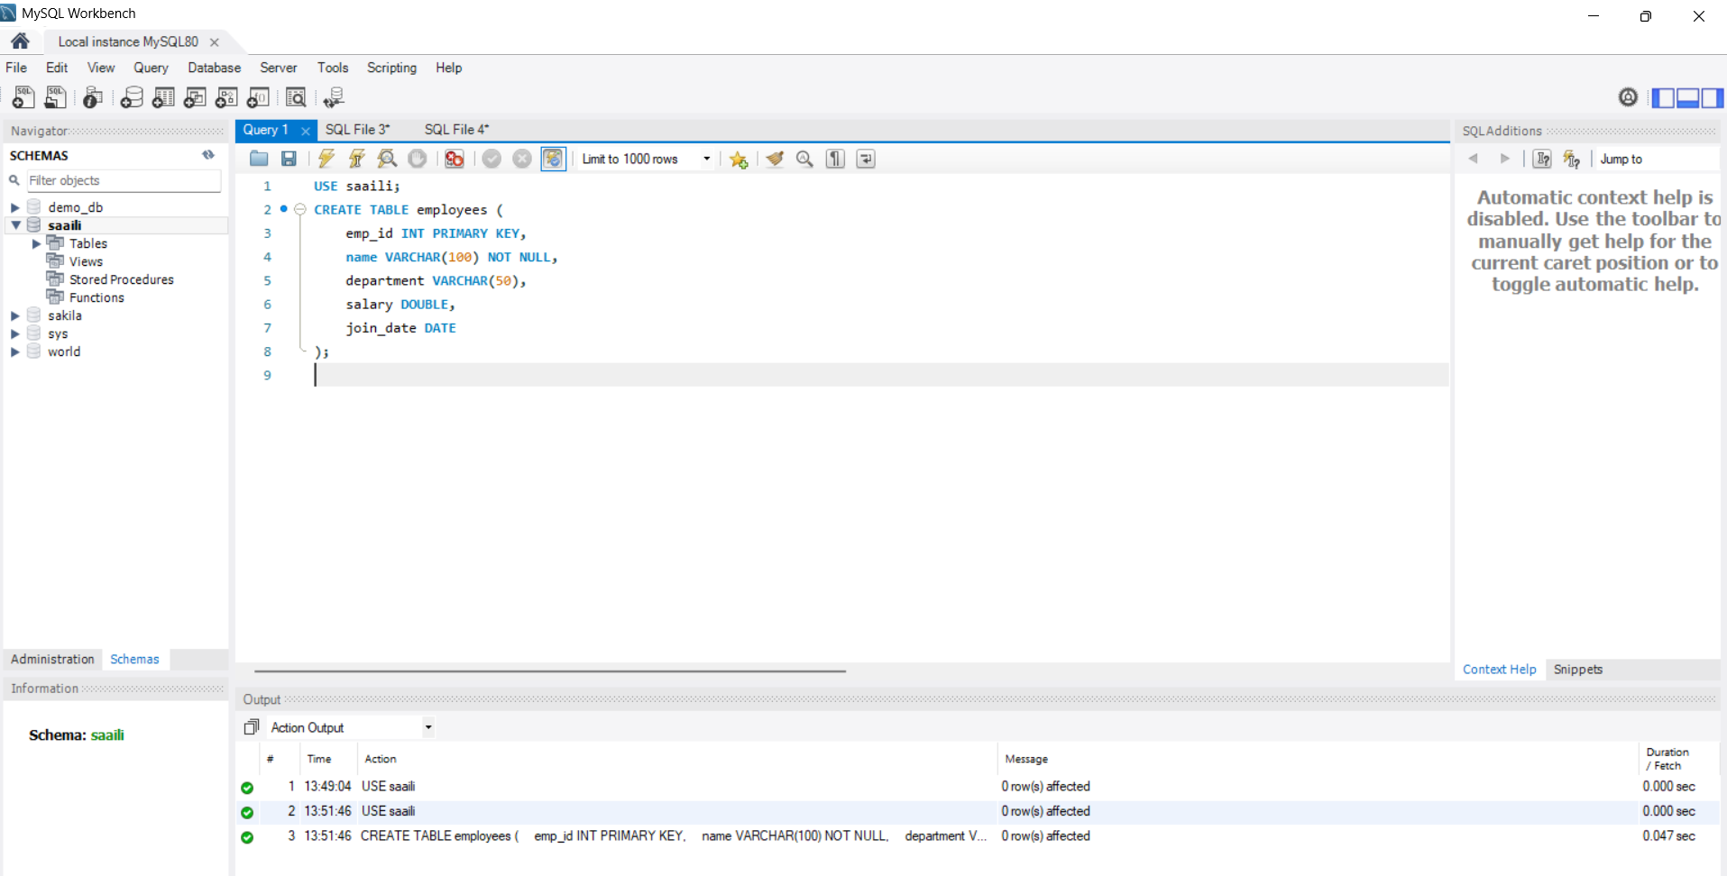

**(2)####INERT data**

**INSERT INTO employees (emp_id, name, department, salary, join_date) VALUES**

**(101, 'John Doe', 'HR', 45000, '2021-06-15'),**

**(102, 'Jane Smith', 'IT', 75000, '2020-01-10'),**

**(103, 'Alice Johnson', 'Finance', 60000, '2019-08-23'),**

**(104, 'Bob Brown', 'IT', 80000, '2022-03-01'),**

**(105, 'Eve Davis', 'Marketing', 55000, '2021-11-05');**

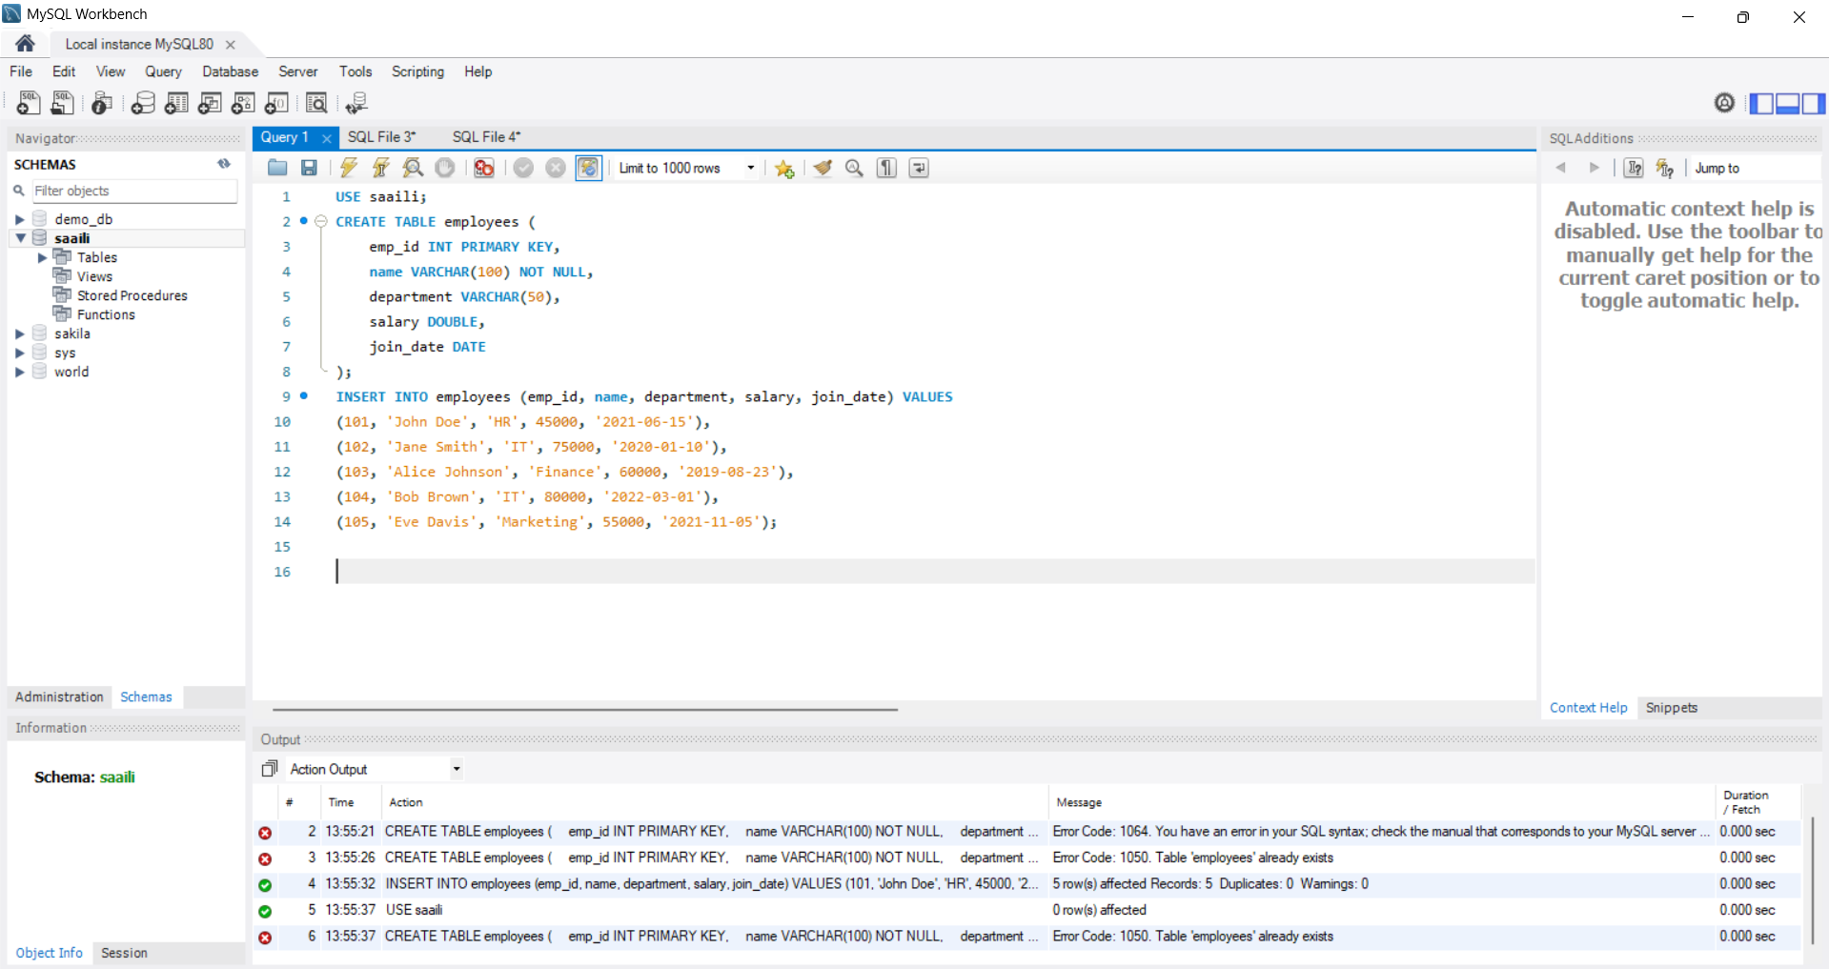

**####QUERY**

**(3) SELECT * FROM employees;**

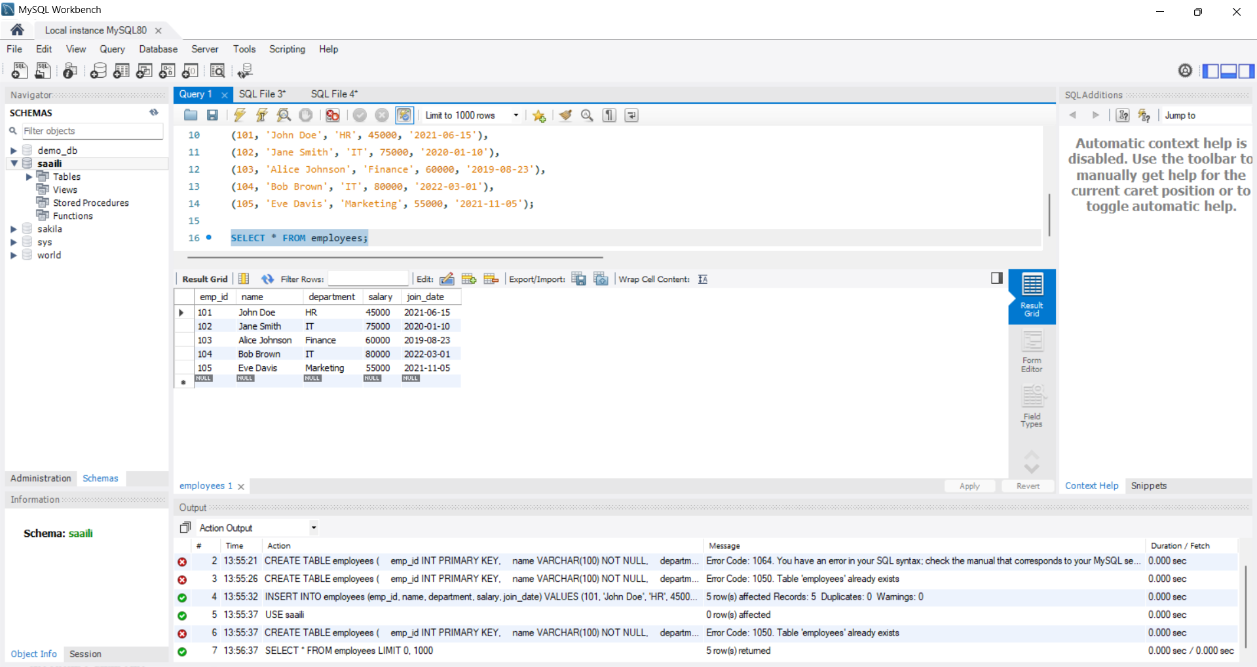

**(4)** **SELECT name, department FROM employees;**

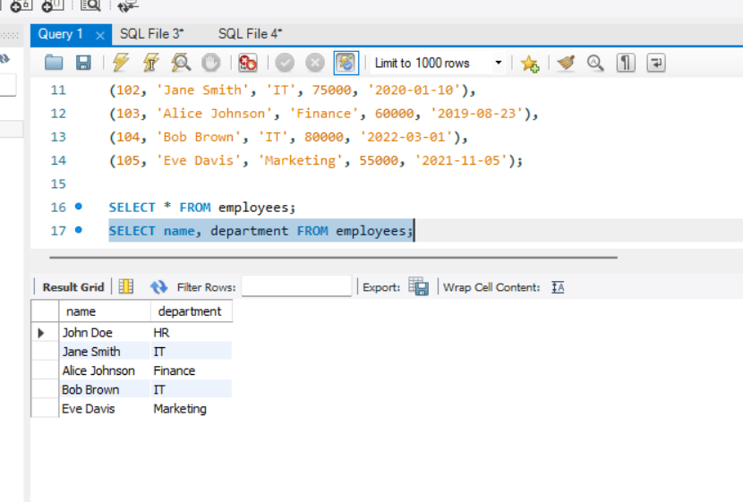

**(5) SELECT * FROM employees WHERE department = 'IT';**

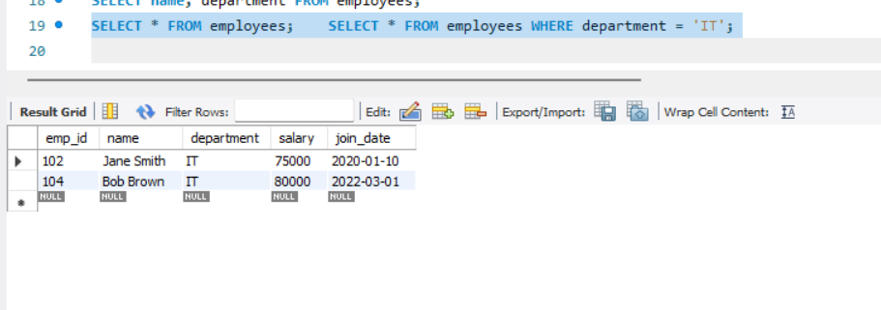

* **(6) SELECT * FROM employees WHERE department = 'IT' AND salary > 75000;**

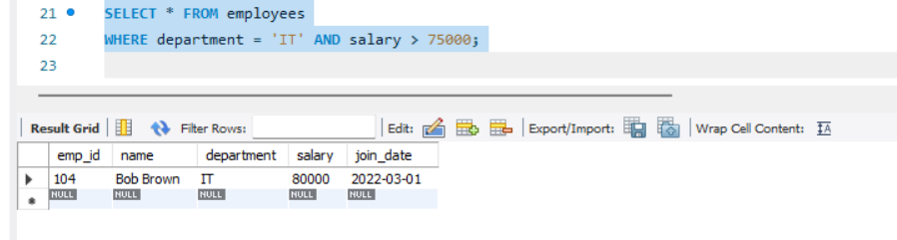

**(7)SELECT * FROM employees WHERE department IN ('IT', 'Finance');**

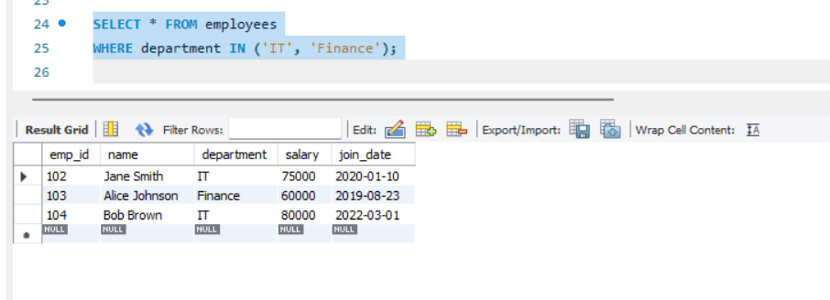

* **(8) SELECT * FROM employees WHERE salary BETWEEN 50000 AND 70000;**

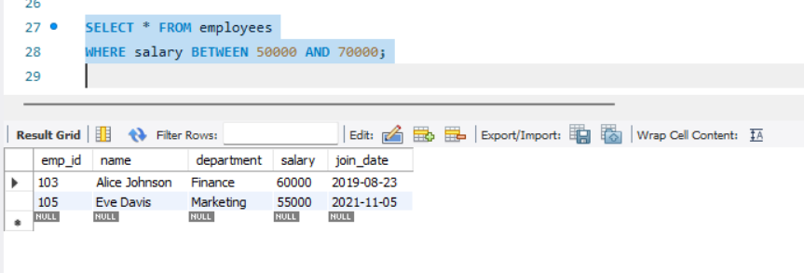

* **(9) SELECT * FROM employees WHERE name LIKE 'J%';**

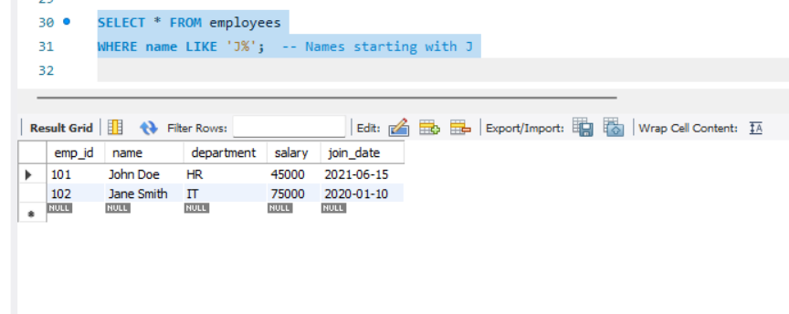

**(10) SELECT * FROM employees**

**ORDER BY salary DESC;**

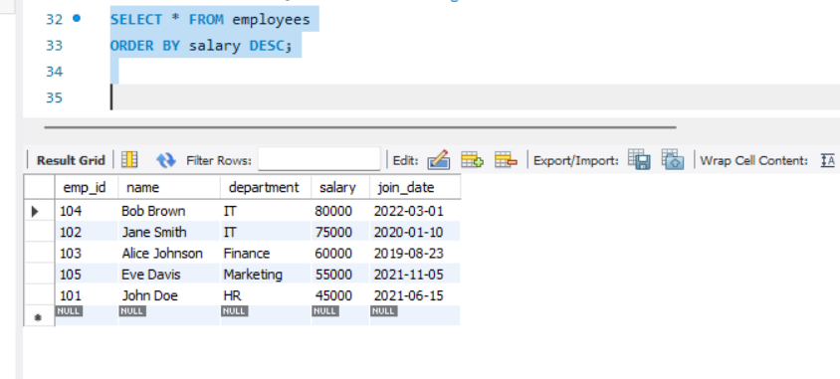

* **(11) UPDATE employees**

**SET salary = 82000**

**WHERE emp_id = 104;**

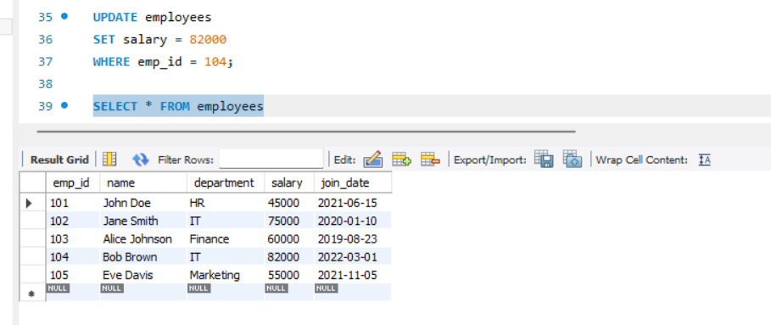

* **(12) DELETE FROM employees**

**WHERE emp_id = 105;**

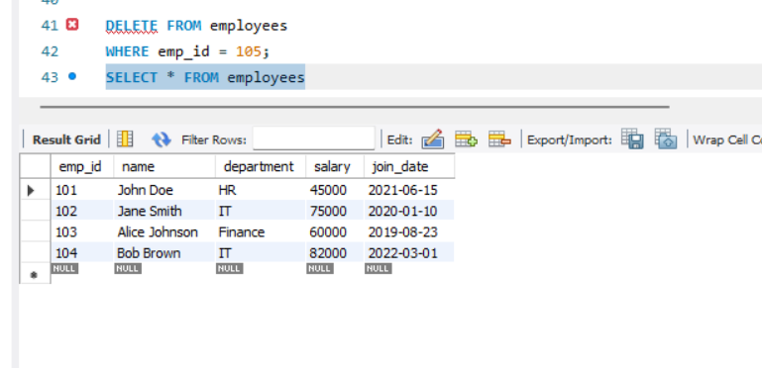

**(13)SELECT department, AVG(salary) AS avg_salary**

**FROM employees**

**GROUP BY department;**

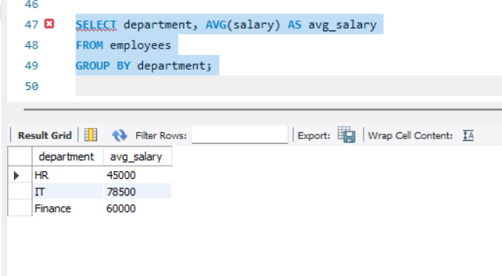

**(14)**

* **SELECT department, COUNT(*) AS emp_count**

**FROM employees**

**GROUP BY department**

**HAVING COUNT(*) > 1;**

